

**Thursday, October 13, 2016**

Reading: read for 10 minutes

Math: math facts

Spelling: study words - test tomorrow

**\*Pack Library Books\***

**Tuesday, October 11, 2016**

Reading: read for 10 minutes

Math: math facts

Spelling: study words

**Monday, October 10, 2016**

Reading: Read for 10 minutes

Math: math facts

Spelling: study words

WEEKLY HOME PRACTICE SHEET: 10/10 - 10/13

**Wednesday, October 12, 2016**

Reading: read for 10 minutes

Math: math facts

Spelling: study words

**Spelling Words:**

top

hop

hot

not

dot

lot

back

pick

oh

yes

Challenge Words

pumpkin

orange

**Robust Words:**

horrible

invigorated

presented

sweltering

aid

persistent

**High Frequency Words:**

find

much

thank

This sheet should remain in your child’s take home folder. I will check to make sure it is signed each day. If there is a reason why your child has not completed their work, please write a note on that day. Thank you!

**SPECIAL SCHEDULE:**

Monday – Music

Tuesday – Art

Wednesday –Gym

Thursday – Gym

Friday – Library

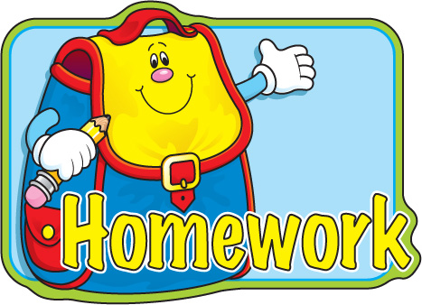

**Special Notes:**

This week is fire safety week, we will be learning all about how to be safe when there is a fire. We will also be learning about Columbus on Monday in honor of Columbus Day. Friday October 14th is our Walk – a –thon during recess. Please send in their permission slip ASAP. We want everyone to be able to participate. Make sure the kids wear their sneakers and their team color!

Please sign

Please sign

Please sign

NO SCHOOL

Please sign